Experiment 14 N.srivaradeepak
Aim 192572075
To implement the Alpha-Beta Pruning Algorithm using Python
Algorithm
- Define the game tree with leaf node values.
- Initialize alpha = -∞ and beta = +∞.
- If the current node is a maximizing node, update alpha with the maximum value.
- If the current node is a minimizing node, update beta with the minimum value.
- If alpha ≥ beta, prune the remaining branches.
- Continue until the root node is evaluated.
- Display the optimal value.

Program
MAX = 1000
MIN = -1000

values = [3, 5, 6, 9, 1, 2, 0, -1]

def alphabeta(depth, nodeIndex, maximizingPlayer, values, alpha, beta):

if depth == 3:
return values[nodeIndex]

if maximizingPlayer:
best = MIN

for i in range(2):
val = alphabeta(
depth + 1,
nodeIndex * 2 + i,
False,
values,
alpha,
beta
)

best = max(best, val)
alpha = max(alpha, best)

if beta <= alpha:
break

return best

else:
best = MAX

for i in range(2):
val = alphabeta(
depth + 1,
nodeIndex * 2 + i,
True,
values,
alpha,
beta
)

best = min(best, val)
beta = min(beta, best)

if beta <= alpha:
break

return best

print("Optimal Value:", alphabeta(0, 0, True, values, MIN, MAX))

Output:

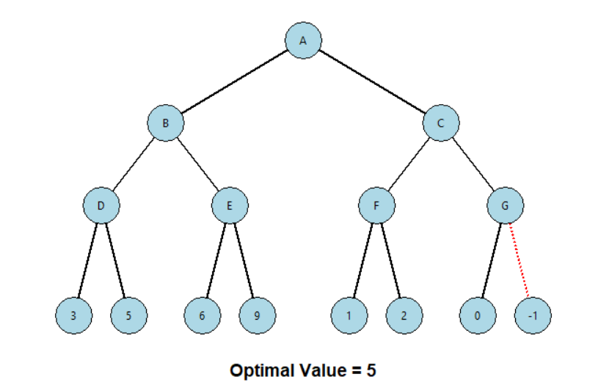

Result:
The Alpha-Beta Pruning algorithm successfully finds the optimal game value as 6, while reducing unnecessary node evaluations.

